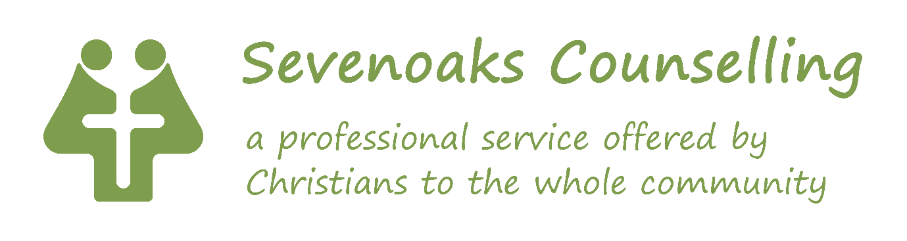
Sevenoaks Counselling - Self Employed Therapists
Sevenoaks Counselling is a counselling charity based in Sevenoaks Kent. We have been operating in Sevenoaks for over forty years, providing a trusted, professional, affordable service to Sevenoaks and the surrounding area including Kent, Medway, South London and parts of Sussex and Surrey. We work with a variety of clients from adults, couples and families to children and young people.
Due to high demand for our services and the retirement of longstanding members, we are looking for self-employed therapists to grow our therapy team, in particular therapists with expertise working with adults plus couples and/or children & young people.
We are looking for experienced therapists BACP/ACC/ UKCP members or equivalent, accredited or working towards accreditation status. Applications are welcomed from counsellors, psychotherapists, counselling psychologists, family therapists and play therapists.
Self-employed contract, 3 to 15 client sessions per week, blend of F2F at our premises in Sevenoaks and phone/online. We are looking for a therapist who can offer sessions within the following times: Monday from 2-8pm, Tuesday from 2- 8pm and Friday morning. £24.50 to £28.70 per client counselling session, depending upon experience, plus up to £90/month contribution towards supervision costs (prorated).
Sevenoaks Counselling is a Christian organisation and as such it is a requirement that therapists are sympathetic to the Christian ethos of the service. Closing date for application is 23rd February 2026.
For more information and an application form please contact Danusia Atkinson, Head of Counselling at info@sevenoakscounselling.org.uk.

